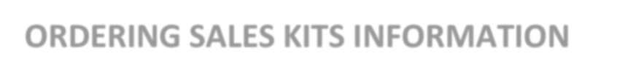

Devoted Health

- Go to the https://portal.mypropago.com/register/devotedhealth?sessionTimeOut=true

- Log in using the center section: For Brokers and Devoted Sales Agents.

- Your username is your NPN (National Producer Number) & password is your Date of Birth

- Select 2024 Enrollment kits and follow the steps.

